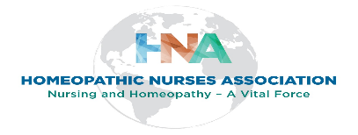

MENTOR Application

Applicant Information
Full Name: |  |  |  | Date:
 | Last | First | M.I.

Address:
 | Street Address | Apartment/Unit #

 | City | State | ZIP Code

Phone: |  | Email

HNA Member since:

Homeopathic Education
Homeopathy School: |  | City/State/Country:

From: |  | To: |  | Did you graduate? | YES | NO | Diploma:

Homeopathic Board Certification From: |  | City/State/Country:

Date Received: |  | Credential:

Nursing Degrees Received From: |  | City/State/Country:

Date Received: |  | Credential:

Homeopathic Practice Information
How long in Practice: |  | Since:

Type of Practice: |  | Other Modalities Used:

Describe Your Current Style of Practice:

Are you able to provide foundational homeopathic education according to Hahnemann’s Organon of Medicine, 5th & 6th edition and other classical doctrines?
 | YES | NO | Describe any issues:

Other Practice Information
Where: |  | From: |  | To:

Type of Practice: |  | Other Modalities Used:

Teaching Experience
Where: |  | From: |  | To:

Courses Taught: |  | Other Information:

Mentoring Experience
Where: |  | From: |  | To:

Approximately how many people you have mentored: |  | Other Information:

Disclaimer and Signature
I certify that my answers are true and complete to the best of my knowledge.
I understand The HNA Mentorship Program Committee may accept or deny the applying Mentor into the Program based on the information in the application. (The HNA Mentorship Program Committee on behalf of the HNA Executive Committee of the Board reserves the right to accept or decline any mentor application). If accepted into the Mentorship Program, I will review and sign the Mentor Agreement and abide by its standards.
Note: There may be times when the Committee may request more information from the applying mentor and/or may request an interview before making a decision. You will also be asked to provide a photo, contact information and descriptive bio for the HNA Mentor Director.
Signature: |  | Date:

For questions regarding this application or the HNA Mentorship Program, please contact mentor@nursehomeopaths.org

